**NODE JS**

**Node.js file**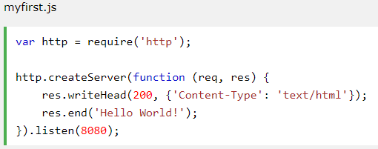

The code tells the computer to write "Hello World!" if anyone (e.g. a web browser) tries to access your computer on port 8080.

**Initiate Node.js File Output**

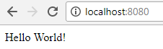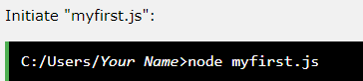

**Node.js Modules**

1. Consider modules to be same as JavaScript libraries.  
2. A set of functions you want to include in your application.  
3. Node.js has a set of build-in modules which you can use without installation.  
4. **INCLUDE MODULES** To include a module, use the require() function with the name of the module:  
    
 Now the application has access to the HTTP module, and is able to create a server:

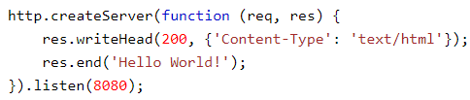

5. **CREATE YOUR OWN MODULES** We can create our own modules, and easily include them in our applications.

For example, this module returns date and time object.

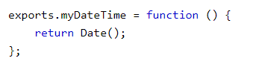 **[ Note:** Use the exports keyword to make properties and methods available outside the module file.]